Operating Systems – Lab 11
Name: Hafsa Salman
Roll no. 22K-5161

Command 01
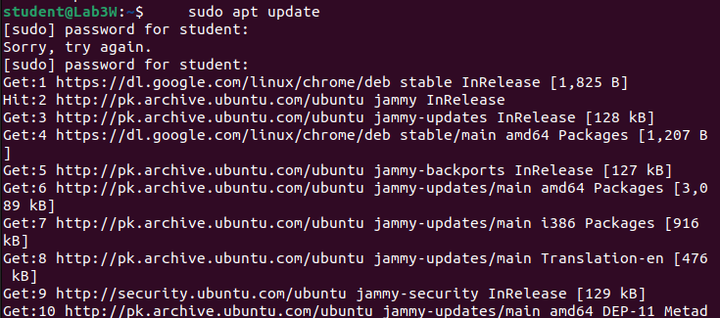

Command 02
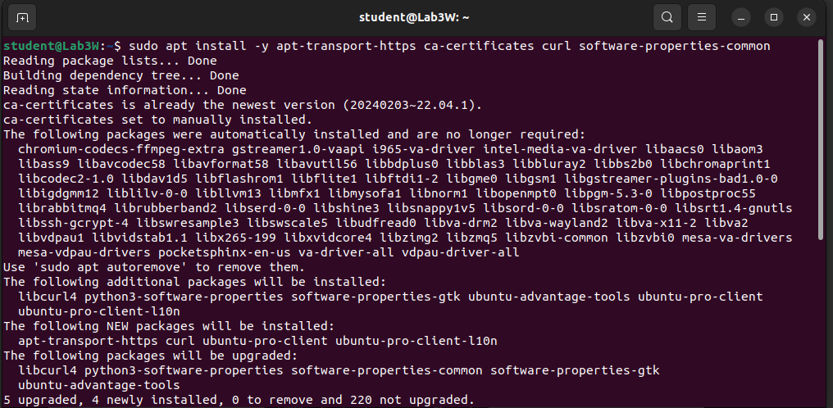
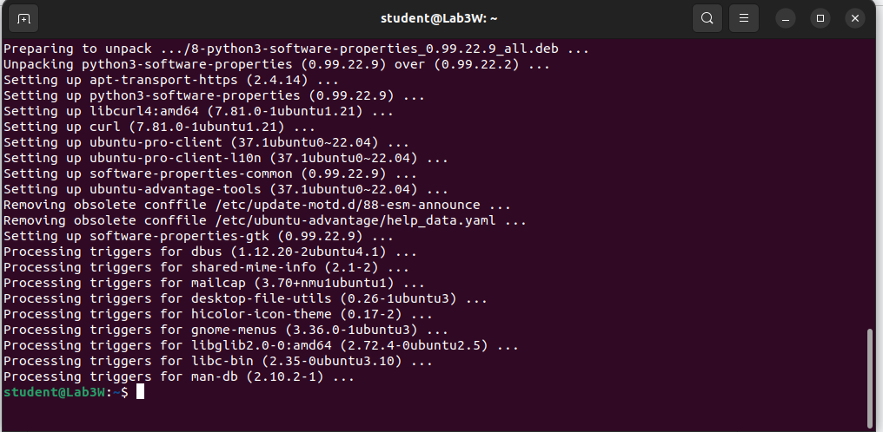

Command 03

Command 04
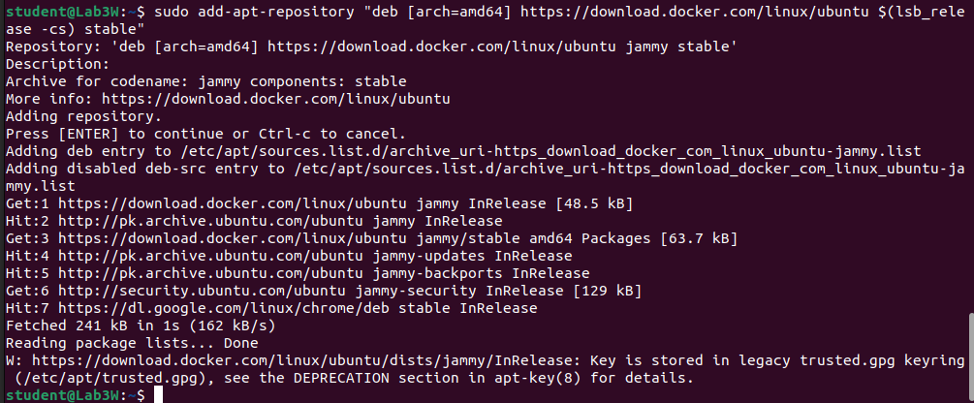

Command 05
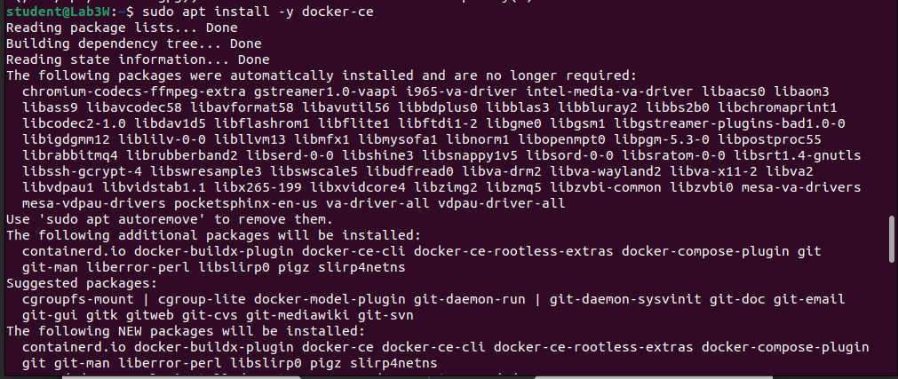
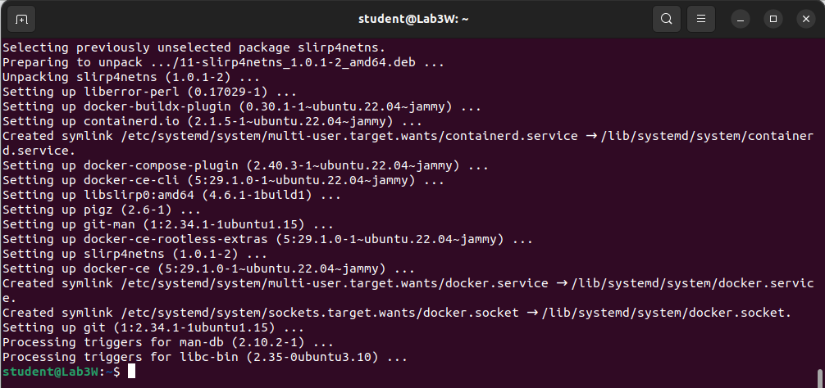

Command 06

Command 07

Command 08
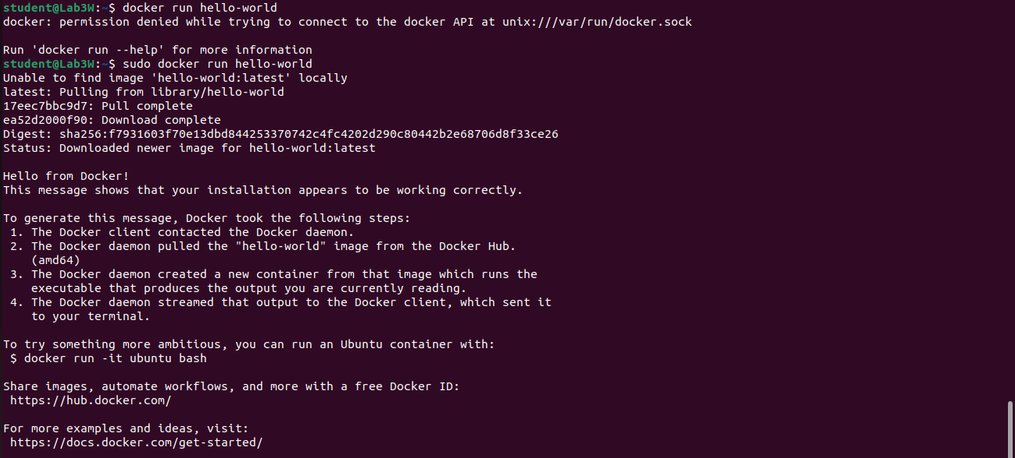

Command 09
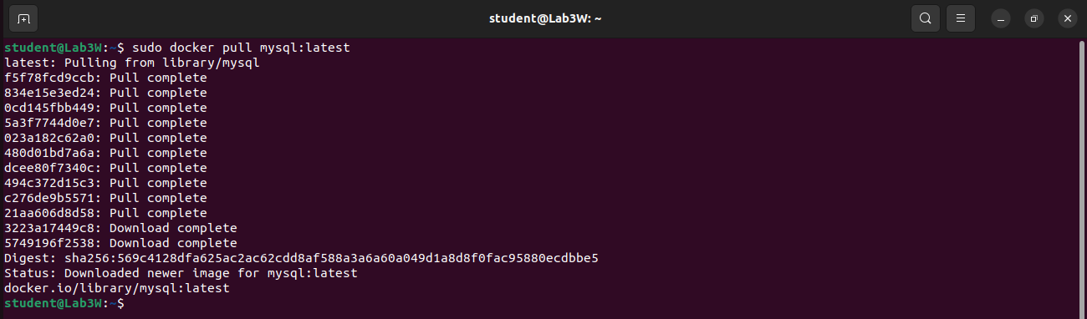

Command 10

Command 11
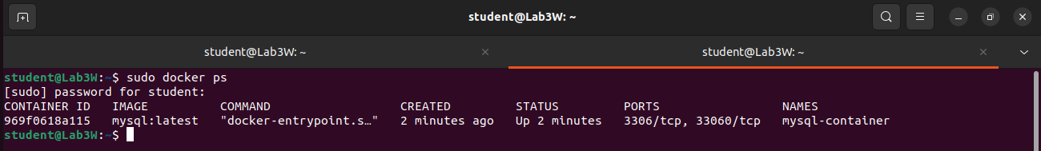

Command 12
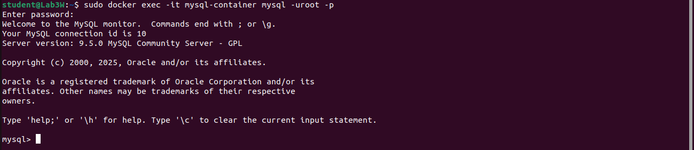

Command 13
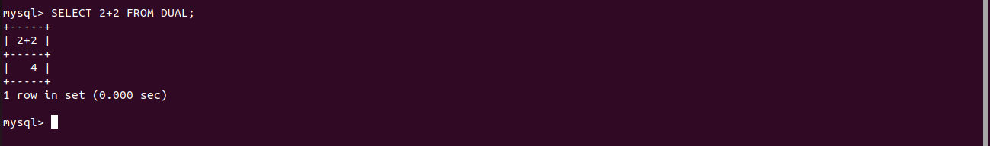

Command 14

Command 15
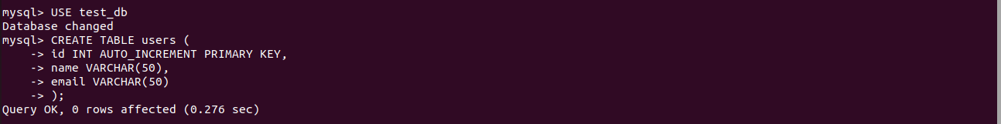

Command 16
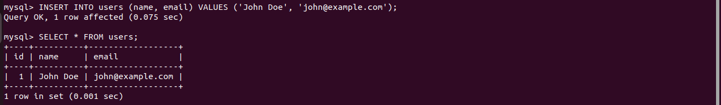

Command 17

Command 18
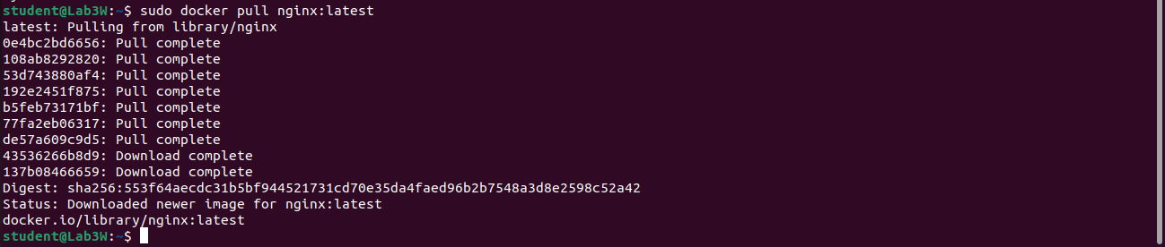

Command 19

Command 20
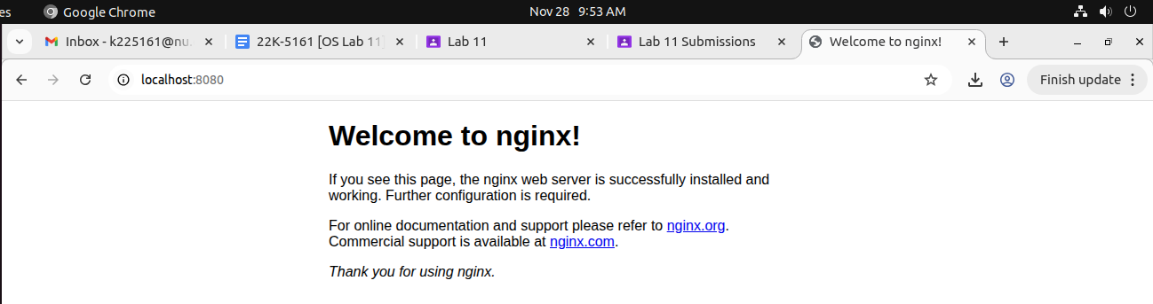

Command 21
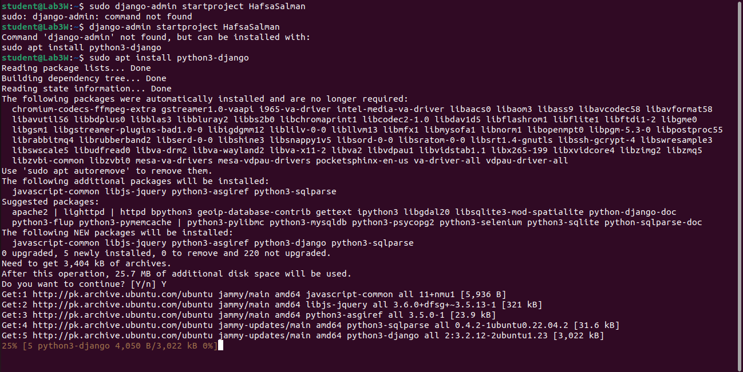

Command 22

Command 23
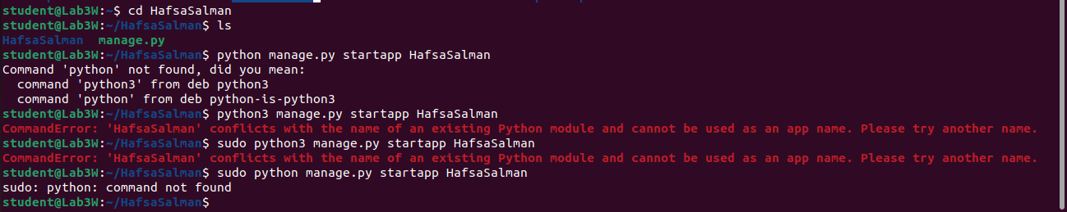

Command 24

Command 25

